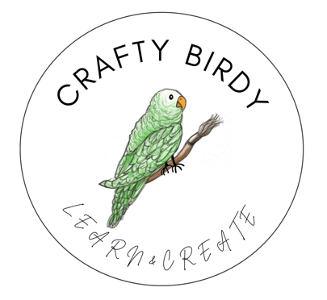

Data Privacy Notice
We do not trade personal data for commercial purposes and will only disclose it if required by law or when necessary to deliver the service you have paid for. To contact CRAFTY BIRDY with data protection query regarding the processing of your personal data, please use the email craftybirdy.learn.create@gmail.com
Details of our processing
We believe that all these purposes are justified on the basis of our legitimate interests in running and promoting the business, our contractual requirements to deliver the agreed services to you, and our legal obligations. The exception is for sending email marketing which we carry out based on consent.
Mailing List and Communications
We use a third-party provider, Wix, to deliver our e-marketing communications. We gather statistics around email opening and clicks using industry standard technologies including clear gifs to help us monitor and improve our e-newsletter.
Bookings
We use third-party provider, Wix, to process your online bookings. We collect your booking information and relevant medical information which we only keep online for the duration of the event. At the end of each season the data is held in secure long-term offline storage to adhere to our legal responsibilities and in accordance with our Data Retention Policy.
Security
We endeavour to take all reasonable steps to protect your personal information. All the data collected by us is stored on secure servers both onsite and in the cloud by the nominated 3rd part providers.
Your Rights
As an individual whose personal data is processed by CRAFTY BIRDY you have these rights:
- The right to be informed, which is what this privacy policy is for.
- The right to access what data we hold about you.
- The right to object to direct marketing - either use the unsubscribe option or contact us directly at craftybirdy.learn.create@gmail.com
- The right to object to processing carried out on the basis of legitimate interests.
- The right to erasure (in some circumstances)
- The right to date portability
- The right to have your data rectified if it is inaccurate
- The right to have your data restricted or blocked from processing
If, at any time, you want to verify, update or amend your personal data please email craftybirdy.learn.create@gmail.com

